Bahria University,

Karachi Campus



LAB EXPERIMENT NO.

**12**

LIST OF TASKS

|  |  |
| --- | --- |
| TASK NO | OBJECTIVE |
| **1** | Design a circuit for different flipflops and verify the truth table for combination of inputs. |
| **2** | What is the difference between Flip-Flop and latch? |
| **3** | What is the difference between synchronous and asynchronous inputs? |
| **4** | What are the applications of different Flip-Flops? |
| 5 | What is the difference of Edge triggering over level triggering? |

Submitted On:

Date: 02/01/2023

**Task No 1 :** Design a circuit for different flipflops and verify the truth table for combination of inputs.

**Truth Table:**

|  |  |  |  |  |  |  |
| --- | --- | --- | --- | --- | --- | --- |
| **SD Preset** | **SD Clear** | **Clock** | **J** | **K** | **Q (OutPust)** | **Q`** |
| L | H | X | X | X | H | L |
| H | L | X | X | X | L | H |
| L | L | X | X | X | H* | H* |
| H | H | | | L | L | Q0 | Q0’ |
| H | H | | | H | L | H | L |
| H | H | | | L | H | L | H |
| H | H | | | H | H | TOGGLE | TOGGLE |
| H | H | H | X | X | Q0 | Q0’ |

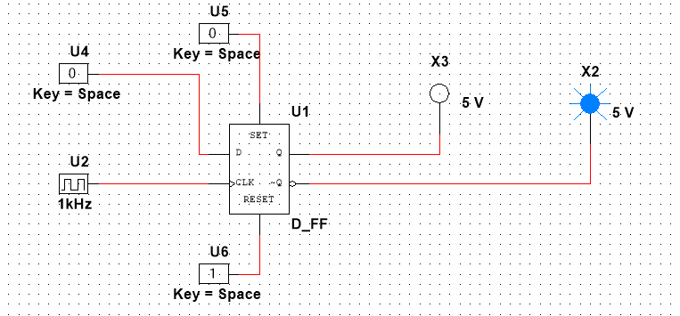**Output:**

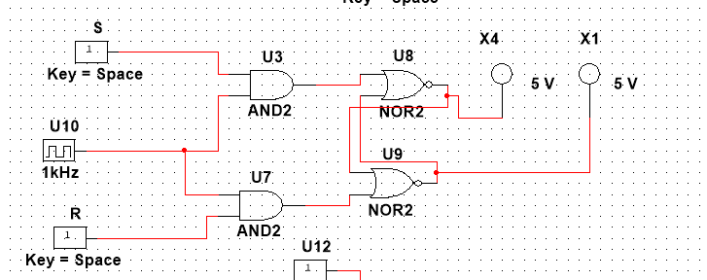

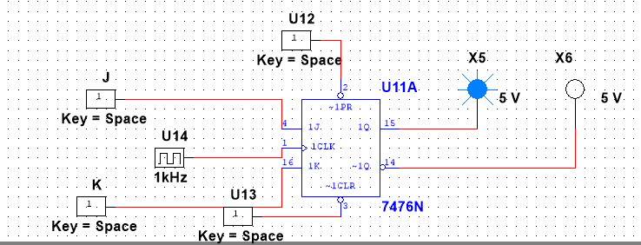

**Task No 2 :** What is the difference between Flip-Flop and latch?

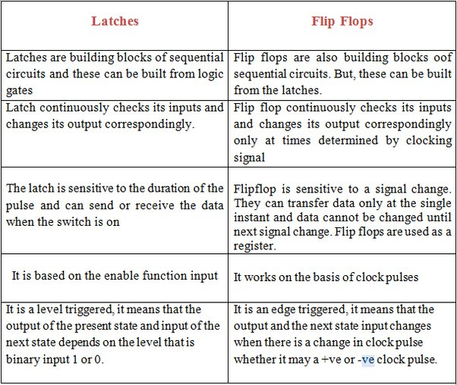

**Task No 3 :** .What is the difference between synchronous and asynchronous inputs?

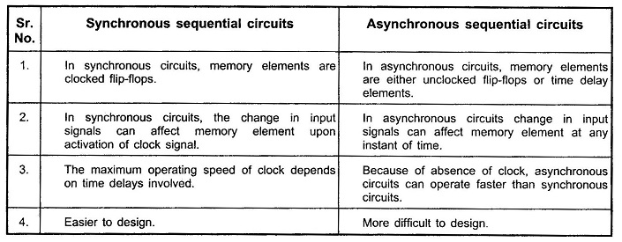

**Task No 4 :** . What are the applications of different Flip-Flops?

**Applications of Flip-Flops**

* Frequency dividers.
* Counters.
* Storage registers.
* Shift registers.
* Data storage.
* Bounce elimination switch.
* Latch.
* Data transfer.

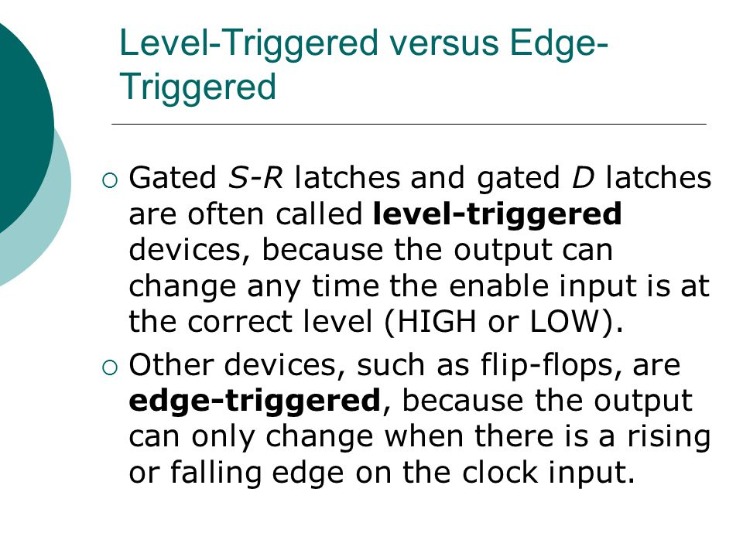**Task No 5:** . What is the difference of Edge triggering over level triggering?